

Salma Aulia Nazhira

210511132

R3/C

**Soal Praktikum :**

1. Buatlah masing-masing 2 contoh jenis pewarisan di luar dari contoh yang telah diberikan, beri

nama:

single1.py, single2.py,

* multiple1.py, multiple2.py,
* hierarchical1.py, hierarchical2.py,
* multilevel1.py, multilevel2,
* hybrid1.py, hybrid2.py

**Jawab :**

**single1.py**

**Script**

# Nama : Salma Aulia Nazhira

# NIM : 210511132

# Kelas : R3/C

class Handphone:

    def __init__(self, merek, warna):

        self.merek = merek

        self.warna = warna

    def berdering(self):

        print(self.merek, "bergetar")

class Samsung(Handphone):

    def __init__(self, merek, warna, harga):

        super().__init__(merek, warna)

        self.harga = harga

    def bergetar(self):

        print("drrrrttt drrrttt")

SamsungA = Samsung("Handphone Samsung", "hitam", "$500.000")

SamsungA.berdering()

SamsungA.bergetar()

**Screenshot**

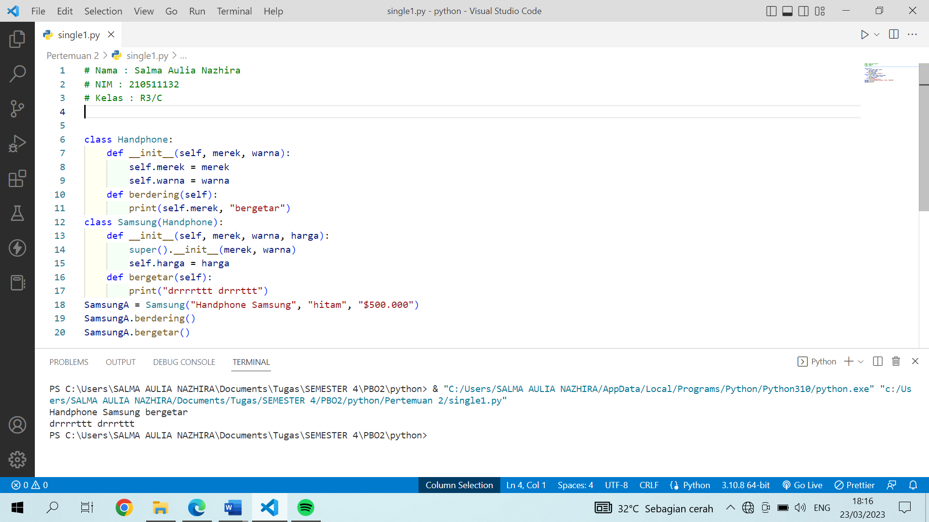

**single2.py**

**Script**

# Nama : Salma Aulia Nazhira

# NIM : 210511132

# Kelas : R3/C

class Human:

    def __init__(self, name, age):

        self.name = name

        self.age = age

    def listening(self):

        print(f"{self.name} is listening to the lesson.")

class Student(Human):

    def __init__(self, name, age, nim):

        super().__init__(name, age)

        self.nim = nim

    def presentation(self):

        print(f"{self.name} with NIM {self.nim} is doing a presentation.")

studentA = Student("Salma", 19, "210511132")

studentA.listening()

studentA.presentation()

**Screenshot**

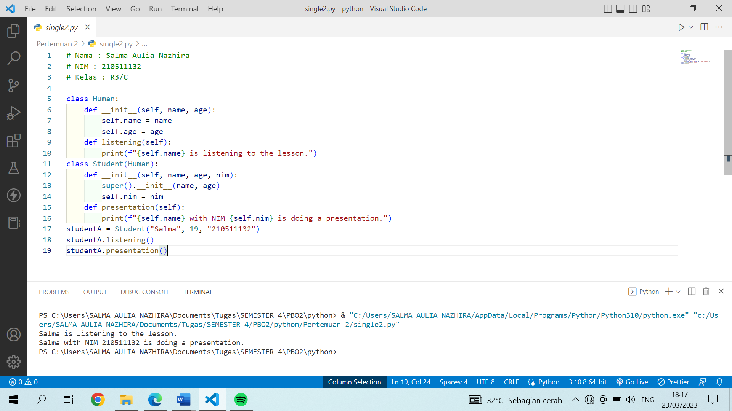

**multiple1.py**

**Script**

# Nama : Salma Aulia Nazhira

# NIM : 210511132

# Kelas : R3/C

class Musik:

    def __init__(self, komposer, jenis):

        self.komposer = komposer

        self.jenis = jenis

    def display_info(self):

        print(f"Komposer: {self.komposer}")

        print(f"Jenis: {self.jenis}")

class Judul:

    def __init__(self, judul, tahun):

        self.judul = judul

        self.tahun = tahun

    def display_info(self):

        print(f"Pekerjaan: {self.pekerjaan}")

        print(f"Gaji: {self.gaji}")

class Komposer:

    def __init__(self, lahir, negara):

        self.negara = negara

        self.lahir = lahir

    def display_info(self):

        print(f"Lahir tanggal: {self.lahir}")

        print(f"Berasal dari negara: {self.negara}")

class KomposerMusik(Musik, Judul, Komposer):

    def __init__(self, komposer, jenis, judul, tahun, negara, lahir):

        Musik.__init__(self, komposer, jenis)

        Judul.__init__(self, judul, tahun)

        Komposer.__init__(self, negara, lahir)

    def display_info(self):

        super().display_info()

        print(f"Berasal dari negara : {self.negara}")

        print(f"Lahir tanggal : {self.lahir}")

        print(f"Judul : {self.judul}")

        print(f"Tahun Rilis : {self.tahun}")

# contoh penggunaan

komposer_musikA = KomposerMusik("Wolfgang Amadeus Mozart", "Klasik", "Piano Sonata No.11", "1784", "27 Jauari 1756", "Austria")

komposer_musikA.display_info()

**Screenshot**

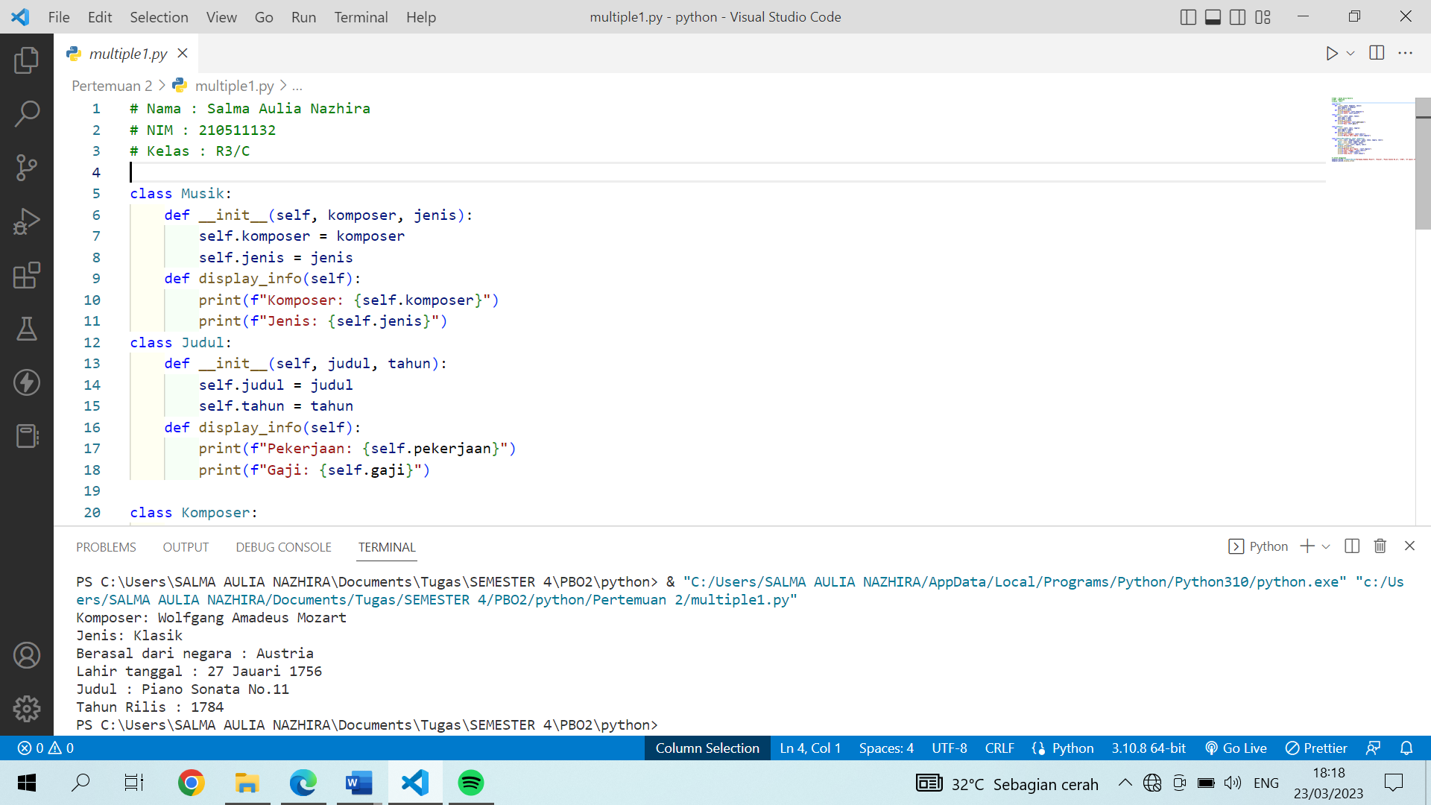

**multiple2.py**

**Script**

# Nama : Salma Aulia Nazhira

# NIM : 210511132

# Kelas : R3/C

class Country:

    def __init__(self, name, capital):

        self.name = name

        self.capital = capital

    def display_info(self):

        print(f"Country Name: {self.name}")

        print(f"Capital City: {self.capital}")

class Language(Country):

    def __init__(self, name, capital, language):

        super().__init__(name, capital, language)

        self.language = language

    def display_info(self):

        super().display_info()

        print(f"Language: {self.language}")

class Currency(Country):

    def __init__(self, name, capital, currency):

        super().__init__(name, capital)

        self.currency = currency

    def display_info(self):

        super().display_info()

        print(f"Currency: {self.currency}")

class Area(Language, Currency):

    def __init__(self, name, capital, language, currency, area):

        Language.__init__(self, name, capital, language)

        Currency.__init__(self, name, capital, currency)

        self.area = area

    def display_info(self):

        super().display_info()

        print(f"Area: {self.area}")

# contoh penggunaan

language_currencyA = Area("Poland", "Warsaw","Polish", "Polish Zloty", "312,679")

language_currencyA.display_info()

**Screenshot**

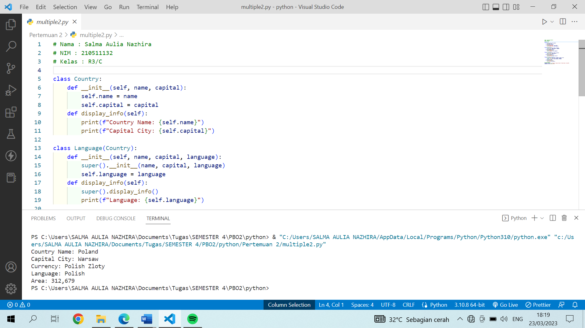

**hierarchical1.py**

**Script**

class Bangunan:

    def __init__(self, nama):

        self.nama = nama

    def get_nama(self):

        return self.nama

class Rumah(Bangunan):

    def __init__(self, nama, luas):

        super().__init__(nama)

        self.luas = luas

    def get_luas(self):

        return self.luas

class Hotel(Bangunan):

    def __init__(self, nama, kamar):

        super().__init__(nama)

        self.kamar = kamar

    def get_kamar(self):

        return self.kamar

# turunan Hierarchical Inheritance

class Kontrakan(Rumah):

    def __init__(self, nama, luas, lokasi):

        super().__init__(nama, luas)

        self.lokasi = lokasi

    def get_lokasi(self):

        return self.lokasi

# turunan Hierarchical Inheritance

class Apartment(Hotel):

    def __init__(self, nama, kamar, jangka_waktu):

        super().__init__(nama, kamar)

        self.jangka_waktu = jangka_waktu

    def get_jangka_waktu(self):

        return self.jangka_waktu

**Screenshot**

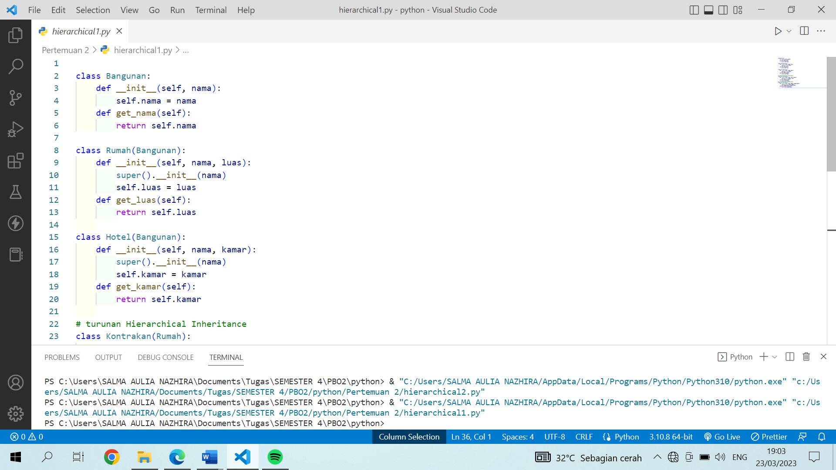

**hierarchical2.py**

**Script**

# Nama : Salma Aulia Nazhira

# NIM : 210511132

# Kelas : R3/C

class AlatElektronik:

    def __init__(self, nama, harga):

        self.nama = nama

        self.harga = harga

    def get_nama(self):

        return self.nama

    def get_harga(self):

        return self.harga

class Handphone(AlatElektronik):

    def __init__(self, nama, harga, warna):

        super().__init__(nama, harga)

        self.warna = warna

    def get_warna(self):

        return self.warna

class Laptop(AlatElektronik):

    def __init__(self, nama, harga, tipe):

        super().__init__(nama, harga)

        self.tipe = tipe

    def get_tipe(self):

        return self.tipe

# Hierarchical Inheritance

class Ipad(Handphone):

    def __init__(self, nama, harga, warna, ukuran):

        super().__init__(nama, harga, warna)

        self.ukuran = ukuran

    def get_ukuran(self):

        return self.ukuran

**Screenshot**

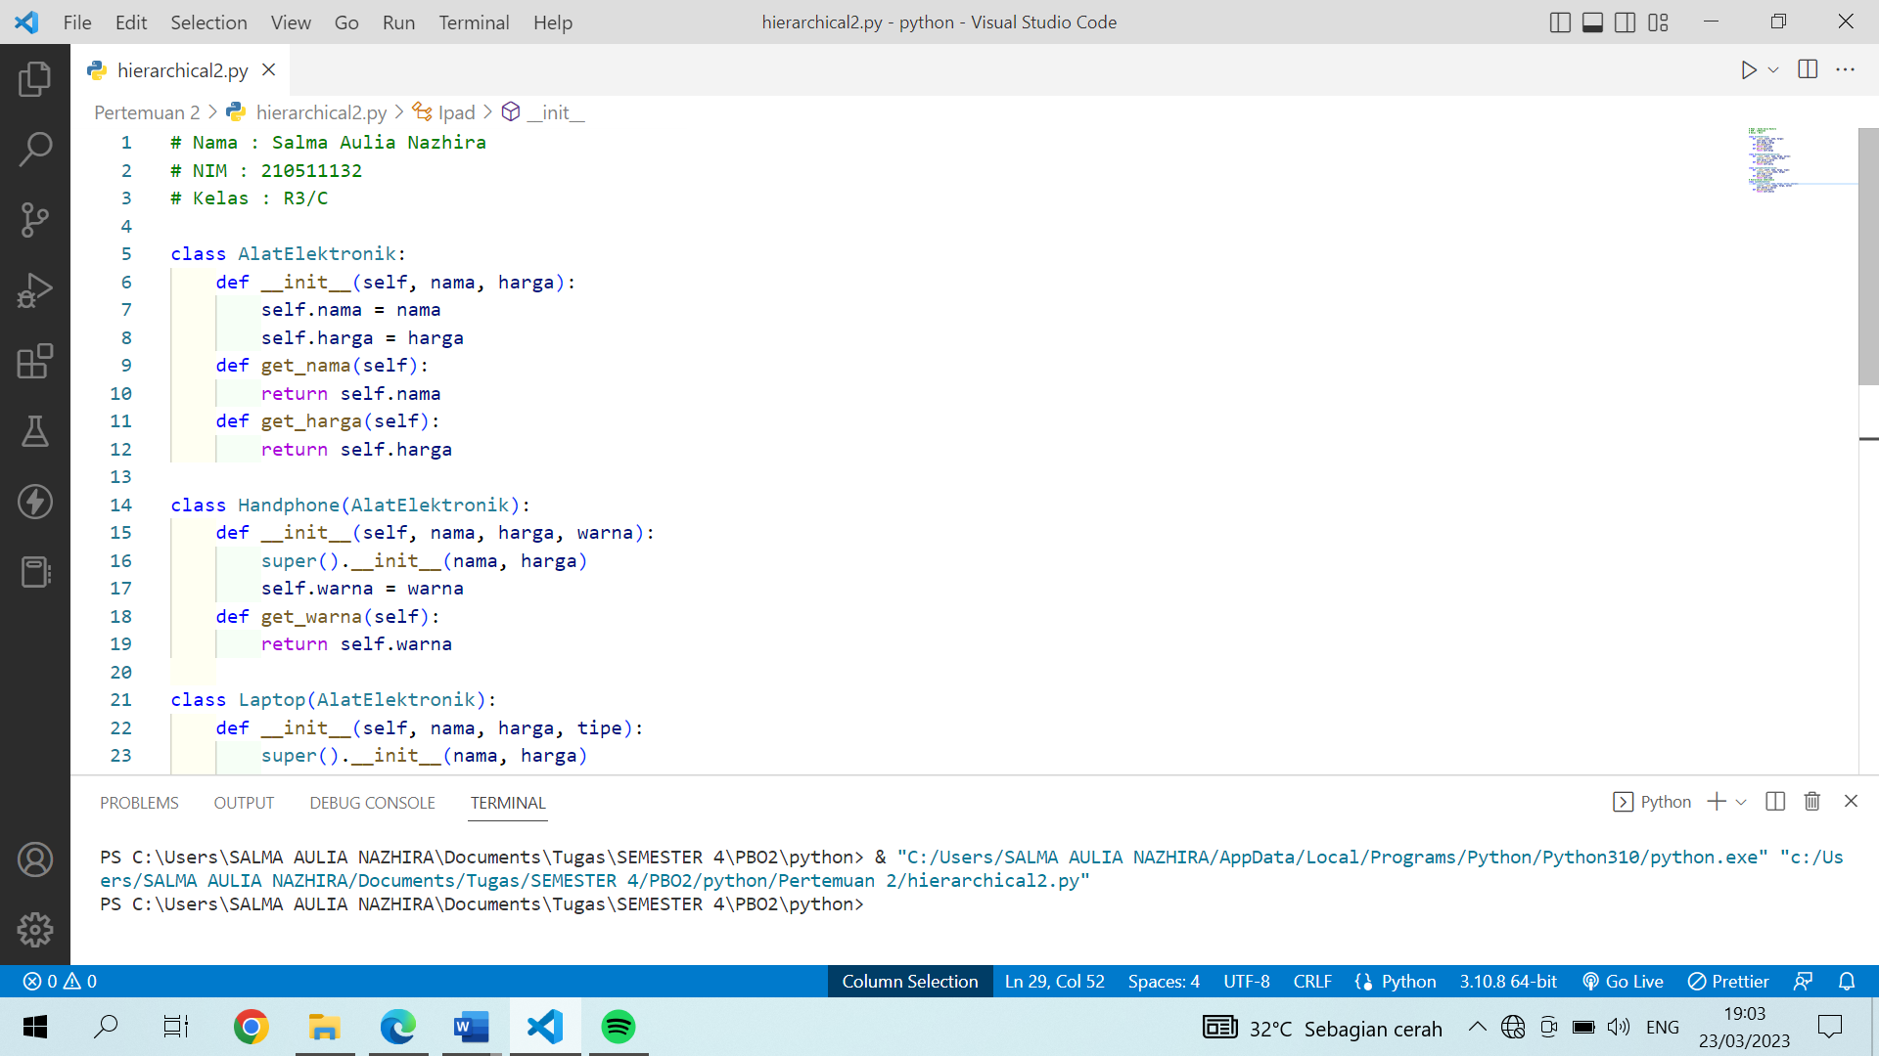

**multilevel1.py**

**Script**

# Nama : Salma Aulia Nazhira

# NIM : 210511132

# Kelas : R3/C

class Makanan:

    def __init__(self, jenis, rasa):

        self.jenis = jenis

        self.rasa = rasa

    def get_details(self):

        print(f"Jenis: {self.jenis}, rasa: {self.rasa}")

class Daerah(Makanan):

    def __init__(self, jenis, rasa, daerah, nama):

        super().__init__(jenis, rasa)

        self.daerah = daerah

        self.nama = nama

    def get_details(self):

        super().get_details()

        print(f"Berasal dari daerah: {self.daerah}, Nama Makanan: {self.nama}")

class Harga(Daerah):

    def __init__(self, jenis, rasa, daerah, nama, harga):

        super().__init__(jenis, rasa, daerah, nama)

        self.harga = harga

    def get_details(self):

        super().get_details()

        print(f"Harga: {self.harga}")

makananA = Makanan("Makanan Olahan", "Asin")

makananA.get_details()

**Screenshot**

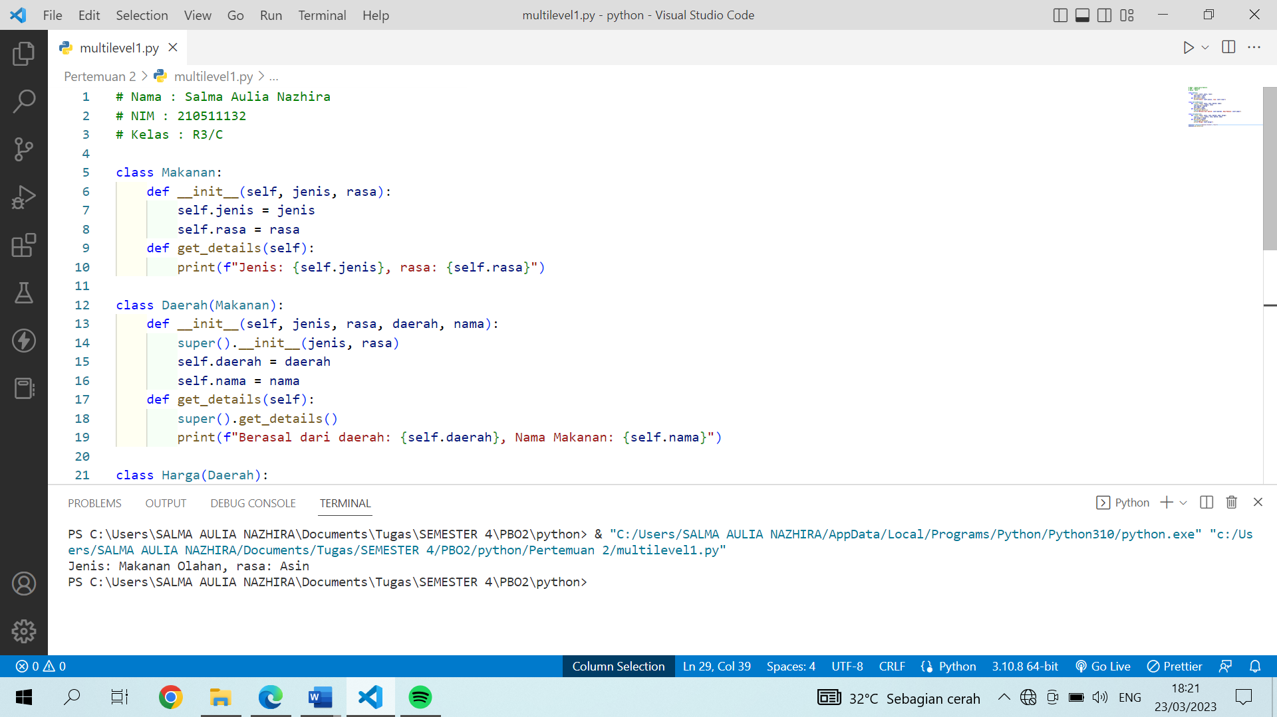

**multilevel2**

**Script**

# Nama : Salma Aulia Nazhira

# NIM : 210511132

# Kelas : R3/C

class Plant:

    def __init__(self, name):

        self.name = name

    def grew(self):

        print(f"the {self.name} grew")

class Flower(Plant):

    def __init__(self, name, colour):

        super().__init__(name)

        self.colour = colour

    def shining(self):

        print(f"{self.name} is shining with a beautiful colour of {self.colour}")

class Damask_Rose(Flower):

    def __init__(self, name, colour, genus):

        super().__init__(name, colour)

        self.genus = genus

    def grew(self):

        print(f"{self.name} is from the genus {self.genus} ")

Damask_Rose = Damask_Rose("Damask Rose", "deep pink", "Rosa")

Damask_Rose.grew()

Damask_Rose.shining()

**Screenshot**

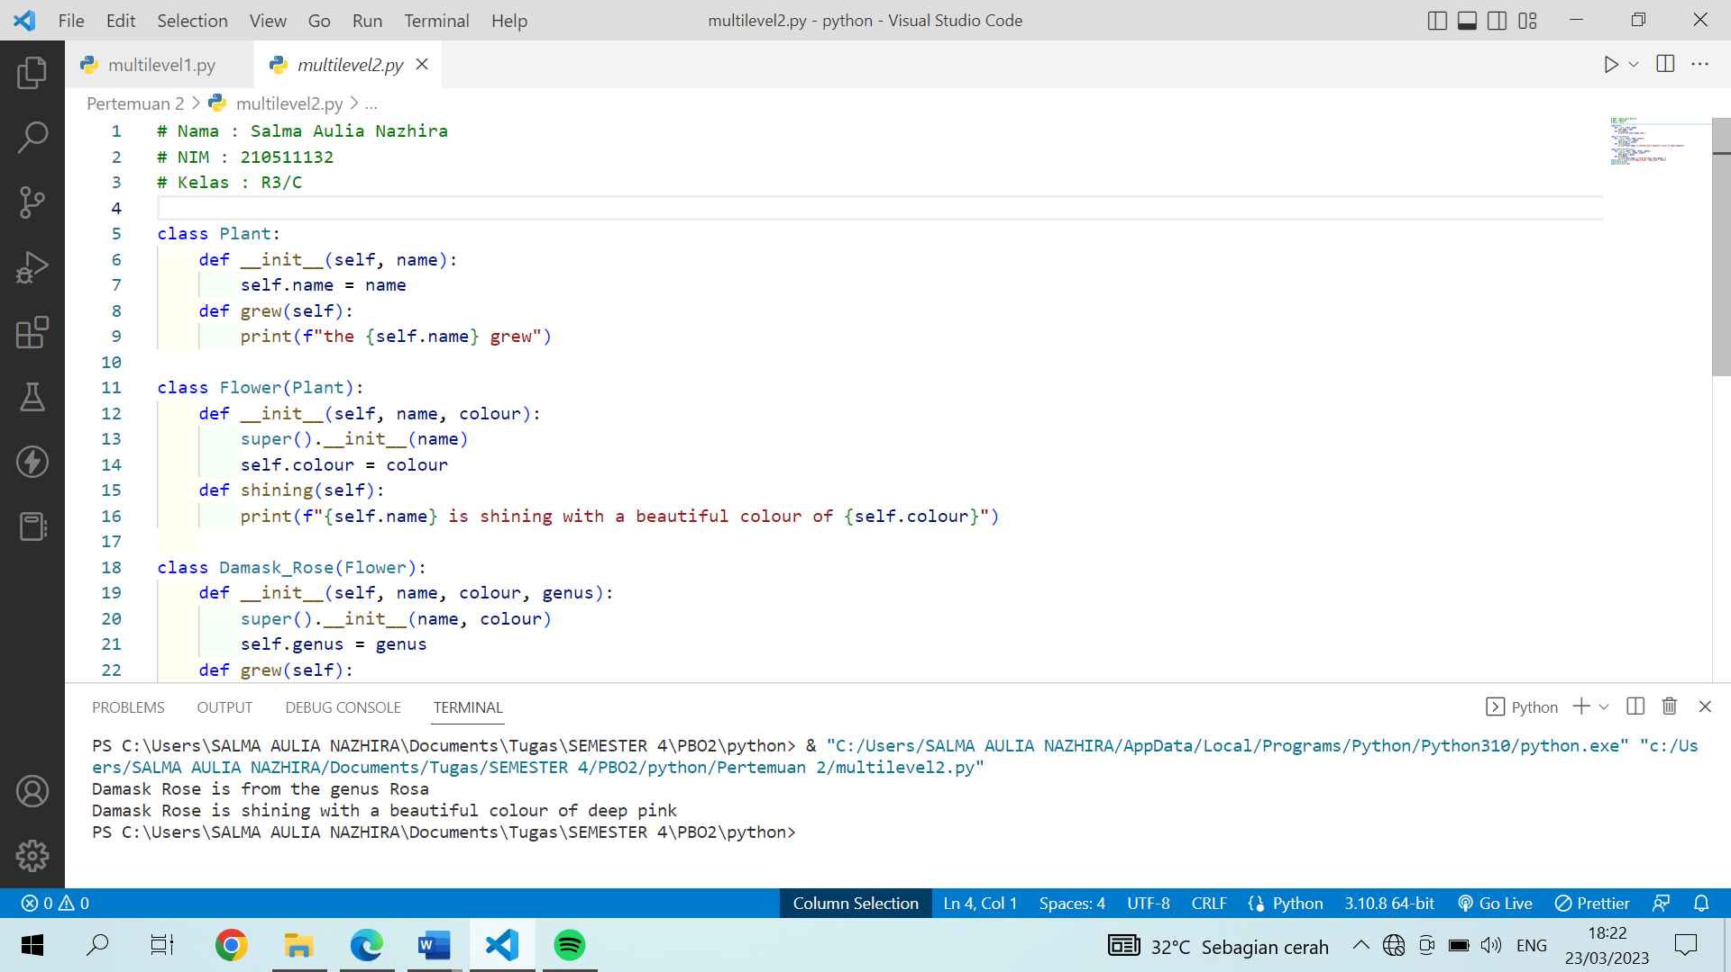

**hybrid1.py**

**Script**

# Nama : Salma Aulia Nazhira

# NIM : 210511132

# Kelas : R3/C

class Minuman:

    def __init__(self, nama, jenis, ):

        self.nama = nama

        self.jenis = jenis

    def get_info(self):

        print("nama:", self.nama)

        print("jenis:", self.jenis)

# Single Inheritance

class Tempat_asal(Minuman):

    def __init__(self, nama, jenis, daerah):

        super().__init__(nama, jenis, )

        self.daerah = daerah

    def get_info(self):

        super().get_info()

        print("Berasal daeri:", self.daerah)

# Single Inheritance

class Variasi(Minuman):

    def __init__(self, nama, jenis, variasi, harga):

        super().__init__(nama, jenis, )

        self.variasi = variasi

        self.harga = harga

    def get_info(self):

        super().get_info()

        print("Variasi:", self.variasi)

        print("Harga:", self.harga)

# Multiple Inheritance

class Bahan(Variasi, Tempat_asal):

    def __init__(self, nama, jenis, variasi, harga, daerah,

    bahan):

        Variasi.__init__(self, nama, jenis, variasi, harga)

        Tempat_asal.__init__(self, nama, jenis, daerah)

        self.bahan = bahan

    def get_info(self):

        super().get_info()

        print("Berasal dari Negara:", self.daerah)

        print("Bahan yang digunakan:", self.bahan)

**Screenshot**

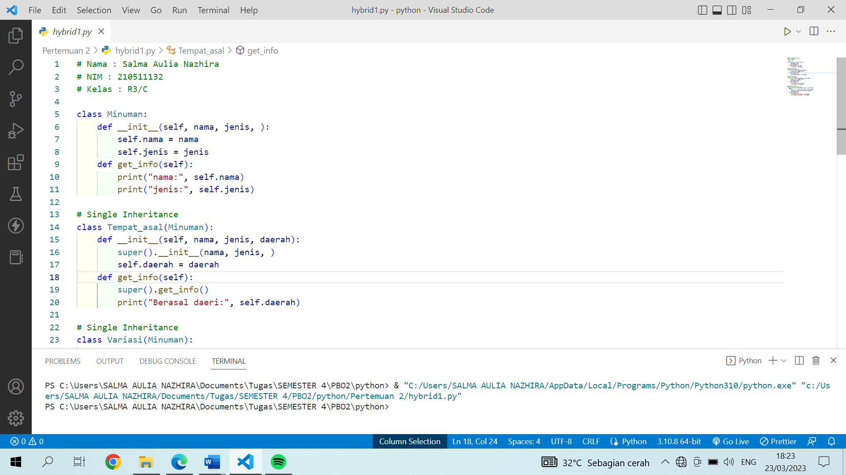

**hybrid2.py**

**Script**

# Nama : Salma Aulia Nazhira

# NIM : 210511132

# Kelas : R3/C

# Single Inheritance

class Calculator:

    def __init__(self, x, y):

        self.x = x

        self.y = y

# Single Inheritance

class Subtract:

    def subtract(self):

        print( self.x, "-", self.y)

# Single Inheritance

class Multiply:

    def multiply(self, dx, dy):

        self.x * dx

        self.y * dy

# Multiple Inheritance

class Divide(Calculator, Subtract, Multiply):

    def __init__(self, x, y):

        super().__init__(x, y)

    def divide(self):

        self.multiply(1, 1)

        self.subtract()

**Screenshot**

